**TASK 3 – GITHUB SETUP**

**Name: Anudeep Vattipalli**

**GitHub Setup:**

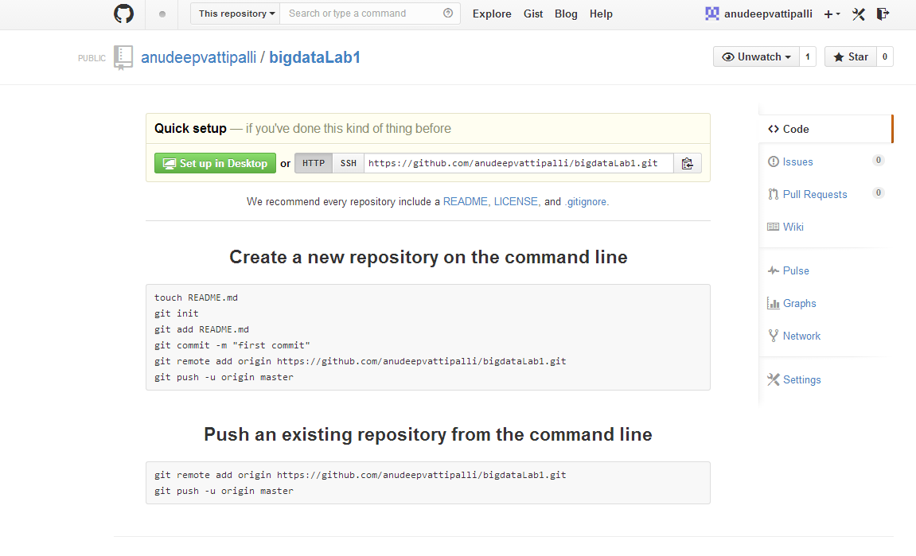

**Commit:**

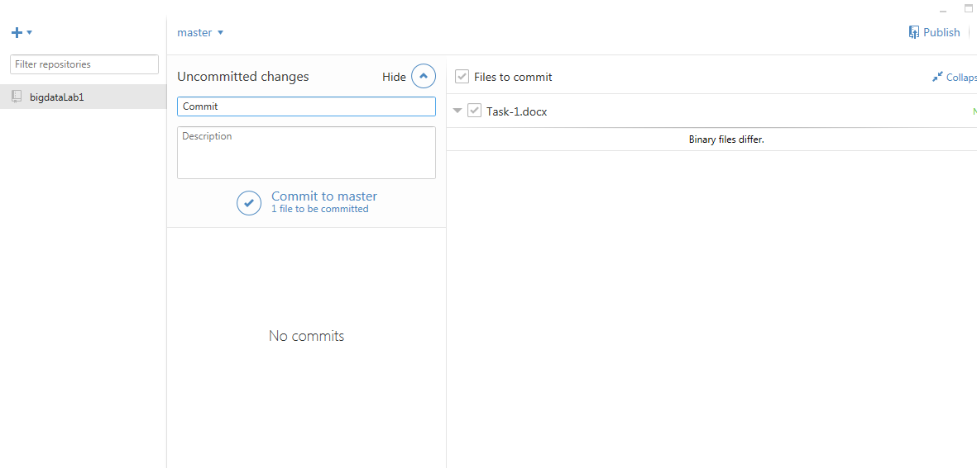

**Publish:**

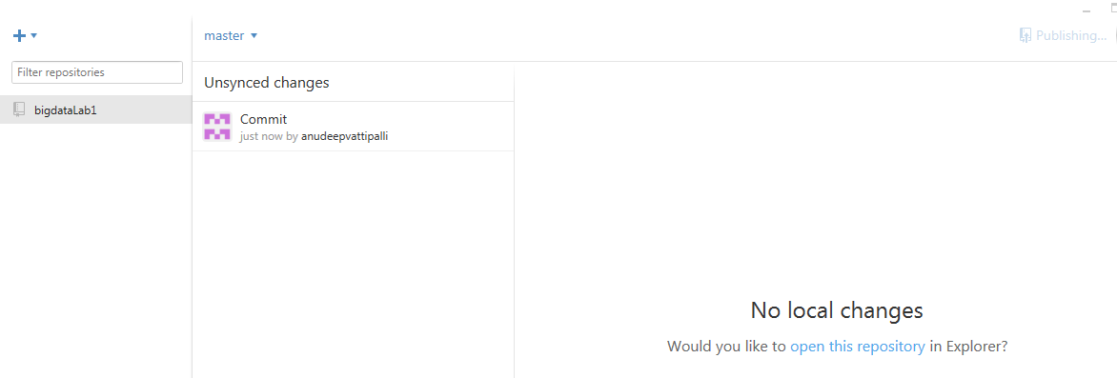

**Sync:**

